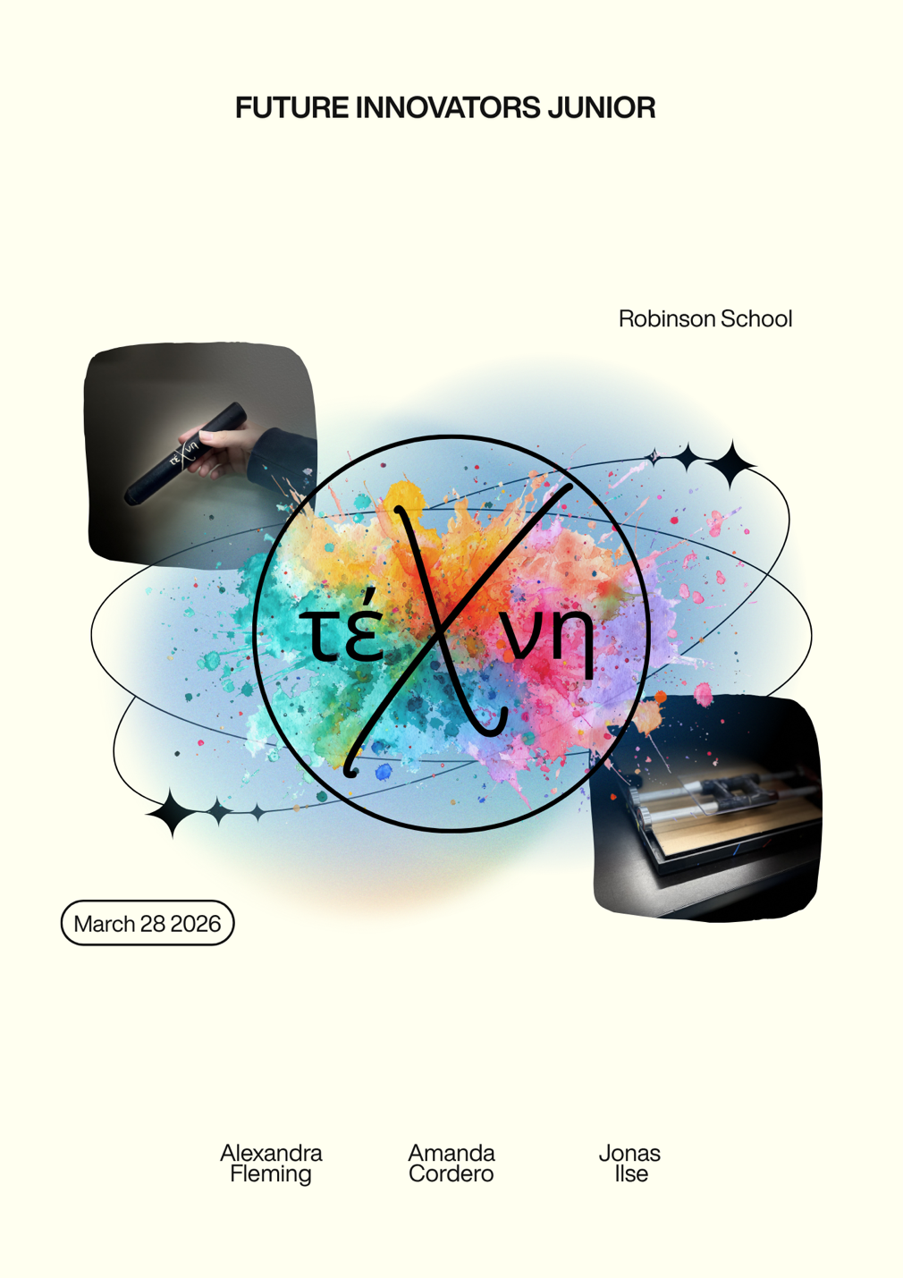

Table of Contents
Team Presentation…………………………………………………………………………. pg. 3
Summary Project Idea………………………………………………………………….. pgs. 4-7
Presenting Robotic Solution……………………………………………………...…….. pgs. 7-9
Social Impact & Innovation……………………......……………………………......… pg. 9-10
Business Plan…………………………………………………...…………………………. pg. 10
Pictures………………………………………………………………...………….……….. pg. 11
Works Cited………………………………...………………………………………… pgs. 12-13

Team Presentation
We are from Robinson School, Puerto Rico
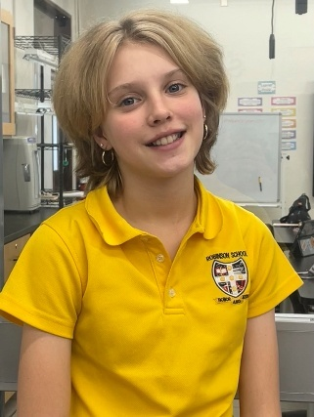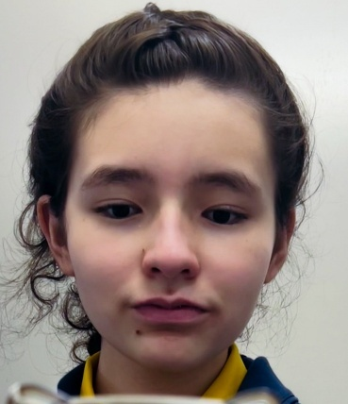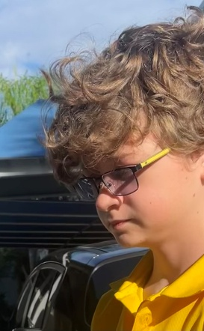

Alexandra Fleming Amanda J. Cordero Jonas Ilse
When dividing the tasks within the team, we were considering strengths and talents within the group. All of us oversaw managing and directing each other so that we could all create the project in equal part.
Alexandra Fleming: Been in robotics for 3 years: Works with ideas, sketching, research, planning, construction, and hardware.
Amanda Cordero: Been in robotics for 3 years: Works with ideas, sketching, research, planning, construction, and hardware.
Jonas Ilse: Been in robotics for 4 years: Works with coding, software, construction, and hardware.

Summary Project Idea
Art has been a part of humanity since the prehistoric era. Art remains as part of social construct, even with all the years, and has also formed all the cultures and stories we still speak of today. This is because humans, as social animals, need to express themselves through different means to have emotional homeostasis. However, as the years pass by, people begin to lose their ability to express themselves through art, be it because of the loss of coordination, precision, weakness of the muscles, loss of force, presence of disease etc. Essential tremors, sarcopenia, Parkinsons, and musculoskeletal disorders (joint deterioration) are examples of illnesses and conditions that cause these symptoms. These conditions cause victims to lose their ability to express themselves through art and it is truly discouraging and disheartening to witness. When someone loses the skill set necessary to paint a clean line or draw a trace where they want it to be, it is just as severe as if someone started to lose their sense of self and means to show who they are to the world. It is like forgetting a language or losing your voice, and can lead to people giving up on art, and on their cultures. We are aware of the severe negative impacts that this issue causes to the disabled and elderly societies and communities, and how it can cause long-lasting negative impacts on their lives. This is why we chose this problem, because we believe it is absolutely crucial that every person on this planet has an equal chance to express themselves, and those who have disadvantages must receive the necessary help. We have witnessed countless elderly people who wish to retire and create art but are unable to because of the negative impacts age as presented to them, including essential tremors.
The Techni products which we have created will efficiently solve this issue by tackling the issue from the side of traditional art and digital art. The project has a plethora of components that work together to ensure the user has a seamless experience. These components are the pen, the screen, the grips for the pen, the mechanical arm stabilizer, and finally the program and app. First off, the pen is designed to efficiently smooth out lines that are inaccurate or shaking using smoothing algorithm. This is happening in real time while the user draws freely on the digital platform. The smoothing algorithm takes into consideration the movements detected by the microcontroller within the pen. While this is happening, in more severe cases, the user can use the mechanical arm stabilizer along with the other components, which is using a mechanism with small wheels and metal tubes and a platform so that the user is able to move across the x axis and y axis of the drawing or painting, while being able to have a platform to rest their hand on to limit shaking. This platform also aids in the issue of having weaker hands, allowing for rest and stabilization. Next, we have the box and screen, which serve not only to collect the pen’s data and to stream the app, but also to store all the products. Not only that, but we also have the grips for the pen, to enable art for even more. If someone is missing a thumb or finger, we have a grip for that, and even if they’re missing both arms, we have a grip for that too. Finally, the code: 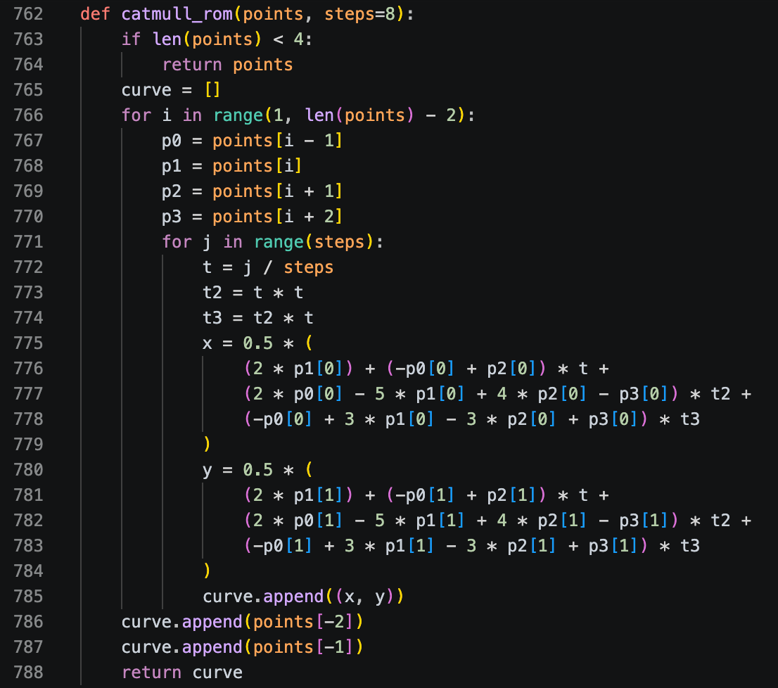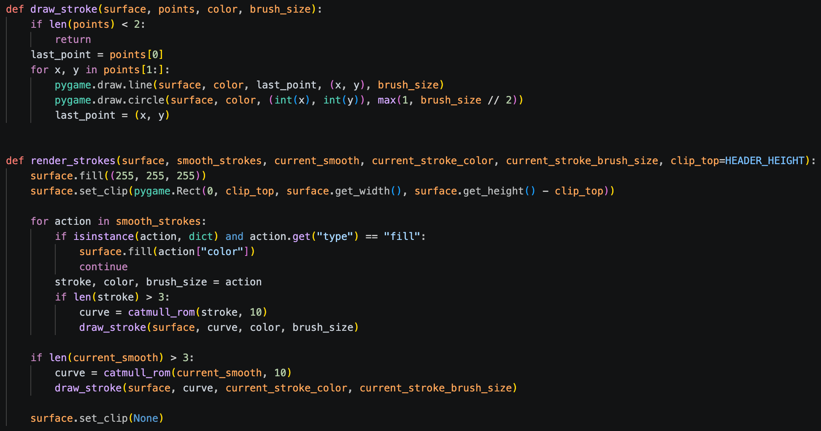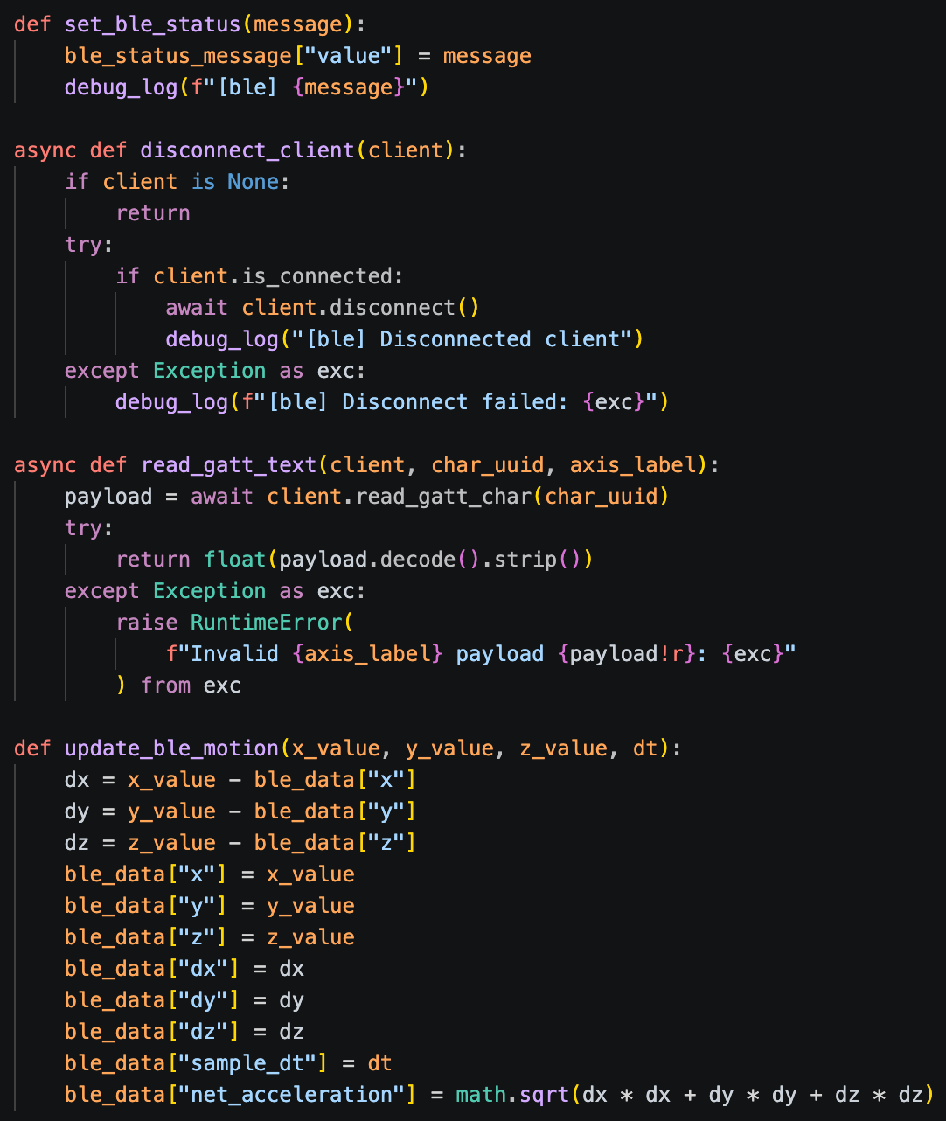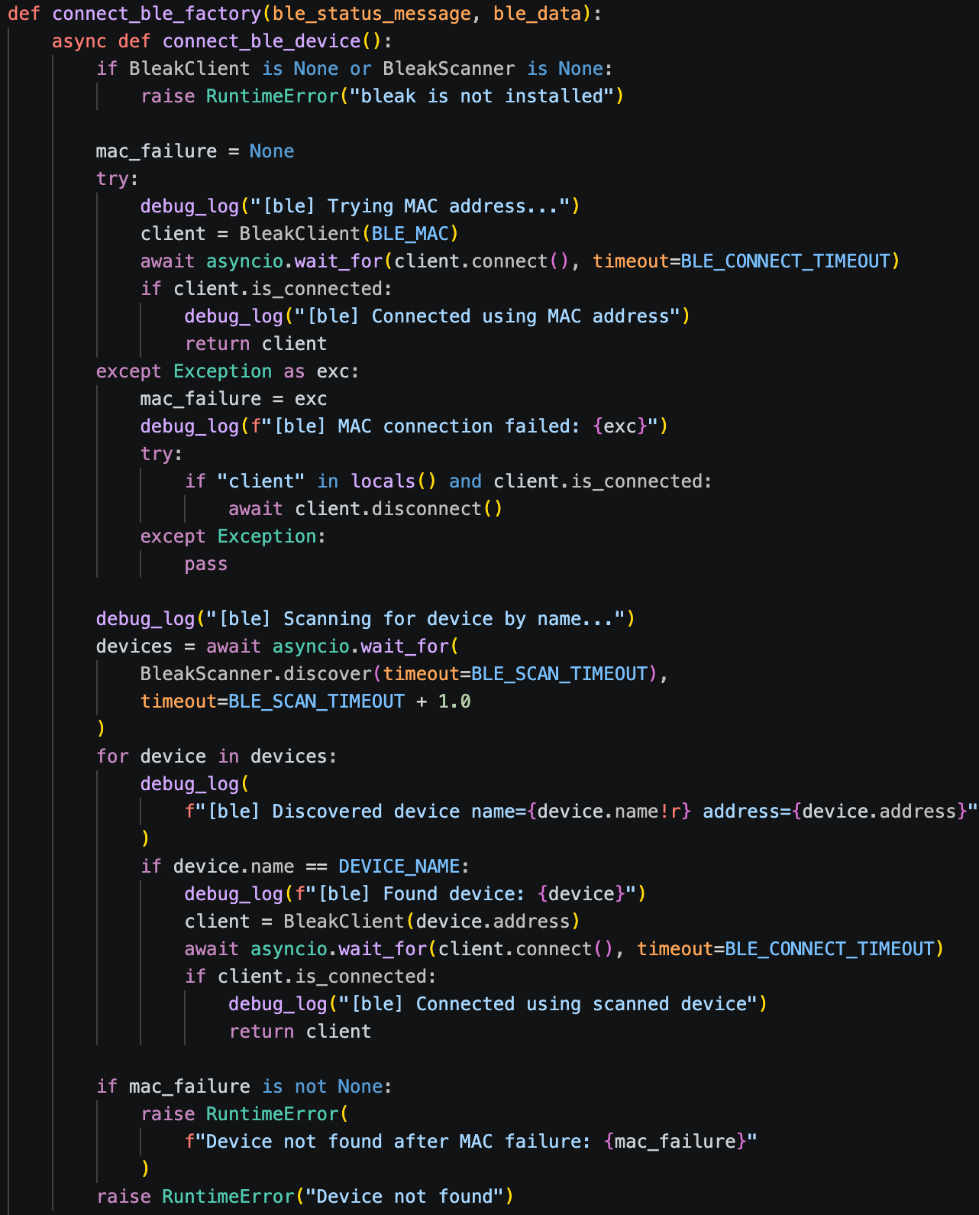
**These are some snippets of the most important sections of the code.**

Our robotics solution is extremely valuable not only to the elderly, but to all people who suffer from a disability which causes shaking, tremors, or weakness.
When our project is properly implemented to be sold, it will make an extremely beneficial difference to the lives of those individuals struggling in these circumstances. They would be able to pursue their dreams; in whatever form of art, they wished. It is mandatory to implement this to the daily lives of those struggling. Our projects could in fact have an impact on the longevity of the lives of elderly people, enforcing brighter emotions, urging them to persevere when life becomes more though. Our projects will overall impact the disabled and elderly communities for the better.
Presenting Robotic Solution
When we were made aware of this year’s theme, at first, we had a plethora of ideas and couldn’t seem to decide between them. We thought of ideas that made physical art with music, projects that would help make daily tasks and everyday objects beautiful and artistic, and origami that would move with music. Our team had some difficulty deciding between ideas- we had so many, and they were all, for the most part, never before done. Ultimately, however, the idea that won out in the end was one that instead of making life more beautiful, helped people make their own lives beautiful through expressing themselves with art. We decided that we wanted to help people who had disabilities or conditions such as those that came with age, or those that came with losing a limb, still make art the way they wished to or used to. What inspired us to choose this idea was mainly that we all knew artists who could no longer perform as well as they once did, and it was heartbreaking to see firsthand the impact that it has on their physical and mental state of well-being. At first, we started considering the ideas that were currently existing as well as tools to help people have a normal life even though they have a condition that prevents them from doing so. Currently, humanity has aimed to solve this problem using a wide variety of solutions. These include Stanford Medicine’s adaptive brain simulations that deliver electrical pulses when needed to reduce effects, Microsoft’s Project Emma, which uses haptic stimulations to disrupt tremors and make hand movements more accurate, or the RT- Ring, a device disguised as a ring that analyzes rest tremors. However, the problem with all of these is that they focus more on disturbing, or diagnosing, the problem rather than aiding the person while they do their preferred activity. Not only that, but most of them helped more with daily tasks, rather than the production of art. Moreover, we decided that we would help not only the aging or those with a disability produce the art they wish to, but also, we decided to enhance experiences for anyone interested in digital art. Therefore, Techni was built. The first component, the pen, is a sleek digital stylus for people with Alzheimer’s disease, essential tremor, and Parkinson’s disease. It uses an Arduino Nano 33 BLE board to connect wirelessly to the display, freeing the movement of the users. This is important because people with Parkinson’s disease and Alzheimer’s disease also commonly have difficulty moving objects with strength, so wireless connection improves the user experience greatly. Our project uses a Catmull-Rom smoothing algorithm to smooth and straighten brushstrokes that the user creates, allowing people with Alzheimer’s disease, Parkinson’s disease, and Essential Tremor to express themselves with ease. This pen also uses a silicon pen tip to interact with the capacitive touchscreen display and further dampen the user’s brushstrokes. The pen uses an accelerometer and gyroscope that measures the user’s hand tremors to adjust the smoothing algorithm’s intensity and customize the experience for each user. The pen component of our project is a relatively thick and very light pen, which allows people with hand movement disabilities to grip the pen and move it around with ease. Overall, this device is designed specifically with accessibility in mind. As we continued to do research on where we could expand on, we noticed, however, that one key tool that has not been changed or modernized since the mid 1500 century is the Mahl stick. It is, in essence, a stick used by painters to keep their hands steady and to keep their paint from being smeared. Humanity has adapted and changed a plethora of things, so it is not comprehensible that such an important part of art has not been adapted as well. Using a Mahl stick and an ‘Etch and Sketch’ for inspiration, we began considering how we could merge the two into a tool old and young artists could use to create clean lines and seamlessly create art. Thus, the hand stabilizer component was born. Inspiration for it, too, came from the fact that we wanted to reach as many people as possible- and subsequentially help as many as possible. This second component of our project aims to help alongside the pen component and screen in more severe cases and acts not only as a replacement for the slightly outdated, yet revered Mahl stick but also helps aging artists fight problems such as essential tremors or Parkinsons by allowing them to use it as a support -to move their arm and create smooth lines while painting or drawing in the app. Subsequentially it, somewhat like an etch and sketch, has two metal tubes that move in the Y and X axes, as well as has two metal tubes with wheels connected to the ends of them that move in the Y axis, as well as tubes attached to the middle of them with a platform to allow movement across the X axis. The platform allows the user to rest their hand to limit their shaking and allow them to create traditional art. In the meantime, the grips and app allow even more people with physical limitations to get the help they need and make their lives beautiful through art. The grips work by helping people with limb loss that prevents them from doing art still do art the way they used to or wish to. Altogether, all of the Techni’s components work together to make the project overall be key and necessary for people with physical limitations that don’t allow them to make art. With Techni, we are expanding diversity and inclusion to art.
Social Impact & Innovation
The Techni Product line-up is innovative, and if implemented into society, it has the potential and ability to change lives. It will help not only people with illnesses or conditions that prevent them from being able to truly express themselves in their preferred medium, but also enhance the experience that any artist, young or old, has overall. Moreover, most people that don’t directly study art retire to paint or draw find themselves unable to do what they’ve yearned to do their whole lives, but couldn’t because of work, because conditions such as essential tremors, Parkinsons, etc. For example, in an art class a member of our team frequented, there were some elderly women who their whole lives had dedicated themselves to art, but now that they had finally reached the skill level they had been hoping to achieve their whole lives, they were no longer able to paint because of essential tremors. This is a problem that Techni could solve. The Techni Products are unique because they tackle an extremely large issue that has not yet been solved properly, in an efficient and creative way.
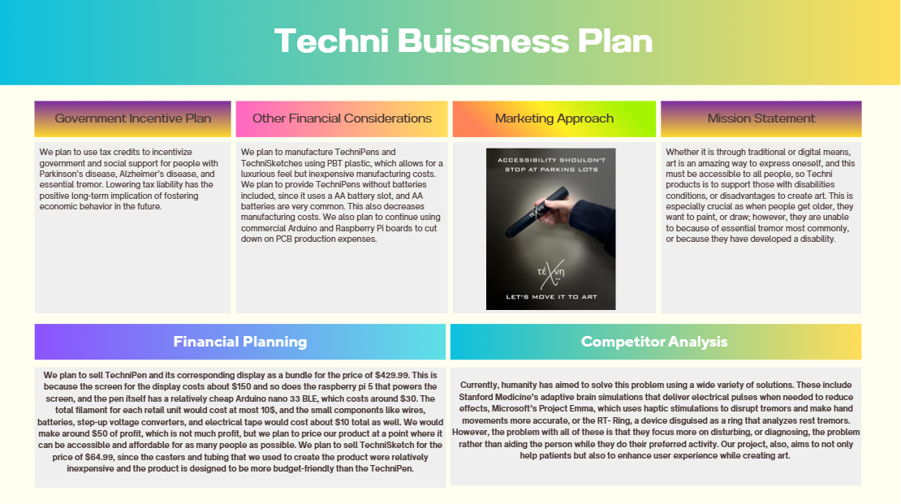
Business Plan

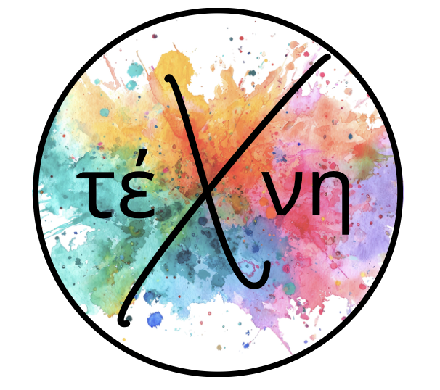Making Art More Accessible for Everyone

Pictures

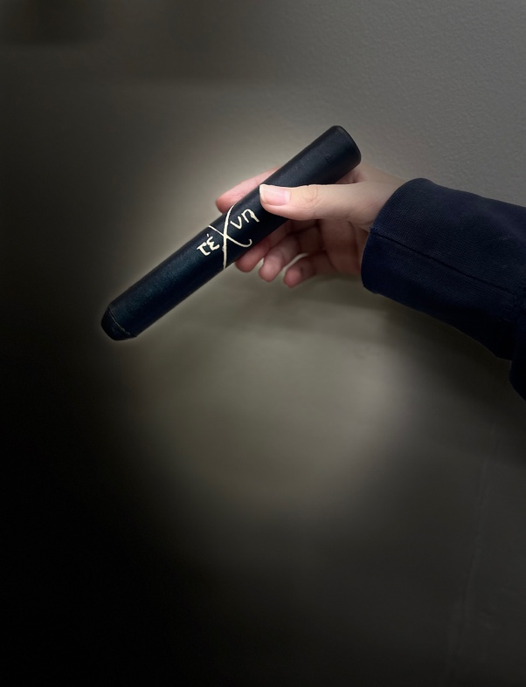
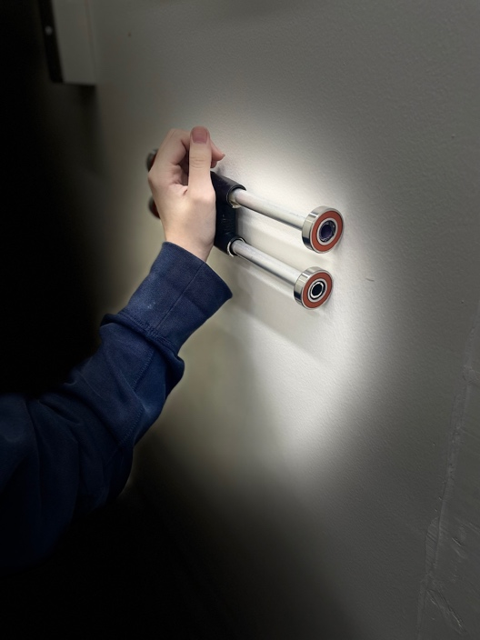

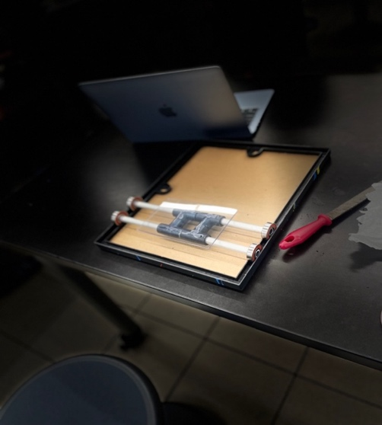

Works Cited

Yoo, Sang-Won, et al. “Exploring the Link Between Essential Tremor and Parkinson’s Disease.” Npj Parkinson S Disease, vol. 9, no. 1, Sept. 2023, p.

“Physical_Therapy_Interventions_for_the_Management_of_Hand_Tremors_in_Patients_With_Parkinson’s_Disease_a_Systematic_Review.” Neurological Sciences, June 2022, pp. 1–10. www.researchgate.net/profile/Mohamed-Gamal-203/publication/364224435_Physical_therapy_interventions_for_the_management_of_hand_tremors_in_patients_with_Parkinson%27s_disease_a_systematic_review/links/633fc7822752e45ef69baaec/Physical-therapy-interventions-for-the-management-of-hand-tremors-in-patients-with-Parkinsons-disease-a-systematic-review.pdf.

“CNN-Based PD Hand Tremor Detection Using Inertial Sensors.” IEEE Journals & Magazine | IEEE Xplore, 1 July 2021, ieeexplore.ieee.org/abstract/document/9411721.

Lewis, SimonJ. G., et al. “Shaken Not Stirred: A Pilot Study Testing a Gyroscopic Spoon Stabilization Device in Parkinson’s Disease and Tremor.” Annals of Indian Academy of Neurology, vol. 23, no. 3, Dec. 2019, p. 409. https://doi.org/10.4103/aian.aian_251_19.

Gilbert, Rebecca, MD PhD. “Wearable Devices That Suppress Parkinson’s Disease Tremor.” American Parkinson Disease Association, 31 July 2024, www.apdaparkinson.org/article/wearable-devices-that-suppress-tremor.

“Essential Tremor.” Cleveland Clinic, 30 Jan. 2026, my.clevelandclinic.org/health/diseases/11886-essential-tremor.

Health Innovation East. “Wearable Tech Device Easing the Symptoms of Parkinson’s - Health Innovation East.” Health Innovation East, 29 Aug. 2024, healthinnovationeast.co.uk/impact-story/wearable-tech-device-easing-the-symptoms-of-parkinsons.

